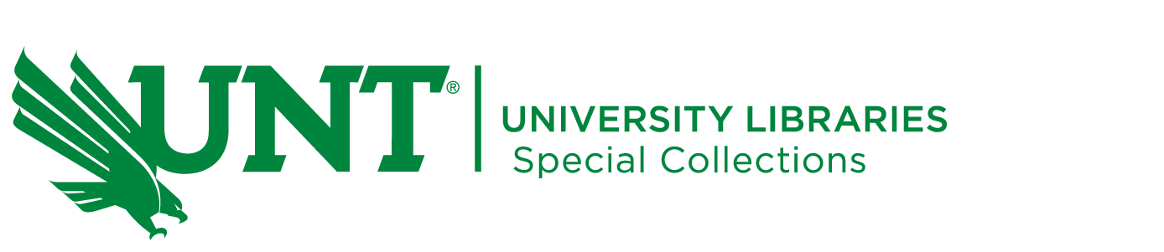

**UNT Summer Archives Institute 2025**

**Dates: Monday, May 27 – Monday, June 30, 2025**

**Time: 9am-3pm (one hour lunch), 5 hours per day, 120 hours total**

**Location: Willis Library - Room 443**

The Summer Archives Institute is an experiential learning opportunity designed to immerse students in hands-on archival work, providing valuable experience and training in professional archival practice within the UNT Special Collections department. Each student will receive training to arrange and describe a unique archival collection. Additionally, each week a Special Collections staff member will lead a discussion about an area of archival practice to provide students opportunities to learn about all aspects of archival work such as preservation, digitization, public service, and instruction. At the conclusion of the Institute students will be asked to give a 3-5 minute “lightning” talk as part of a public presentation.

The Summer Archives Institute will take place on the UNT-Denton campus. Students will work primarily in Willis Library, with some activities taking place at the Library Research Collections Library, also located in Denton. Students will be supervised by Librarians in the Special Collections department.

**What students will gain:**

• Hands-on experience working with an archival collection

• Opportunity to meet archivists and librarians and explore the different aspects of Special Collections work

• Training in archival processing, arrangement, and description

• At the completion of the practicum students will have work products such as processing plans and finding aids suitable for inclusion in an e-portfolio

• Experience presenting their work as part of a “lightning session”

**Students must enroll in the COI Practicum summer section to participate in this institute.**

**Requirements for consideration:**

• Current graduate student at UNT

• Completion of INFO 5371 – Archives and Manuscripts, or comparable introductory archival coursework

• Excellent writing skills—including the ability to analyze content, compose concise descriptions, and proofread

• Thorough understanding of English grammar and spelling

• Facility with visual details

• Ability to pay close attention to detail

**To be considered for the Archives Institute students will need to complete the** [**2025 Special Collections Summer Archives Institute Application**](https://unt.az1.qualtrics.com/jfe/form/SV_etW8gVRLRmJUGjA) **and include:**

* a one-page cover letter describing their interest in the Summer Archives Institute
* a current resume or CV

Four to six graduate students will be selected to participate in this year’s Summer Archives Institute. Applications must be submitted by midnight on Friday, March 28, 2025. Applicants will be notified of their acceptance no later than April 11, 2025.

**Participant Stipend**

We intend to provide a $500 stipend to students who complete the Summer Archives Institute and a certificate of completion.

For more information or questions, please contact Special Collections Public Services Librarian [Meagan May](mailto:meagan.may@unt.edu).